# PowerShell Lab 3

## Execution Policy

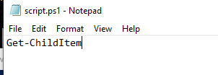

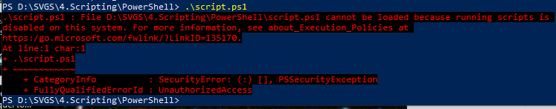

Get-ExecutionPolicy  


Get-Help about_Execution_Policies   
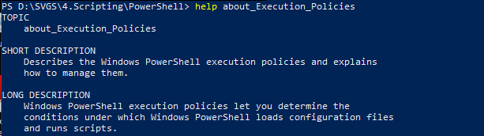  
<snip>

Set-ExecutionPolicy RemoteSigned (must be run as administrator)  
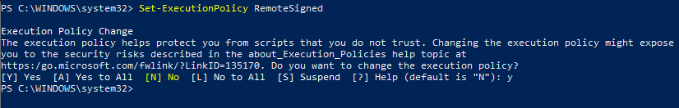

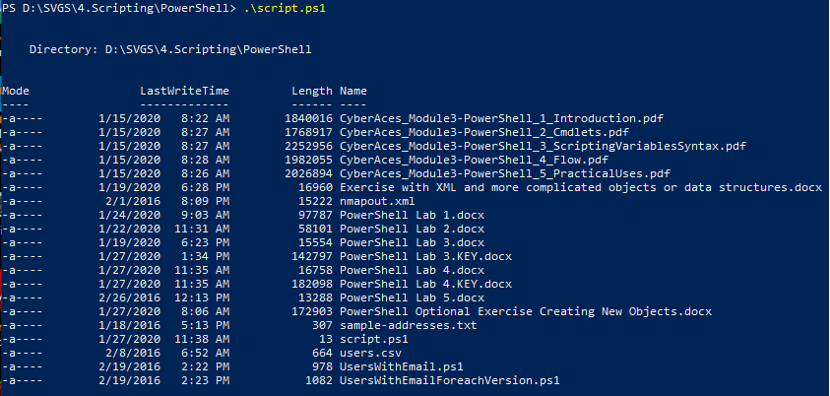

## Syntax, Variables, and Scripting Lesson

## Exercise with data

Quite often in PowerShell, you are working with arrays of data output by commands. For example, you may have the users in a domain, members of groups, or email addresses and accounts from your mail system. We’ll work with some made up users, in the file users.csv from Canvas.

1. Use the cmdlet Import-Csv to load the data from users.csv into a variable ($myvar = Get…)
2. Look at the structure of the variable by piping it into Get-Member. There should be three properties.  
   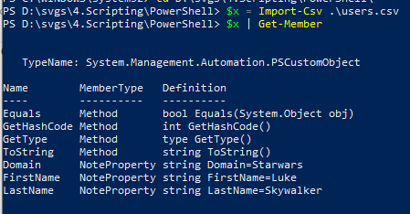
3. You can see all the data by typing the variable name ($myvar or whatever you called it.)  
   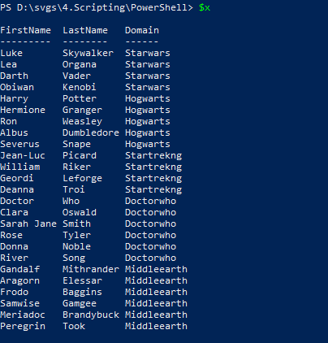
4. You can see one property of the data by typing a period after the variable name followed by the property ($myvar.property). Make a list of first names.  
   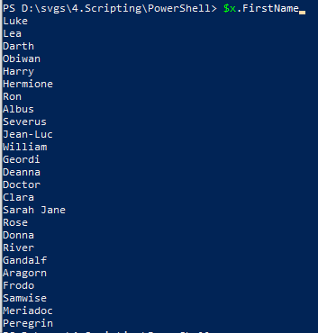
5. You can see the first user by using [0] ( $myvar[0] ), or the last name of the first user by typing $users[0].lastname. What is the last name of the fourth user? (Remember you start counting at zero)  
   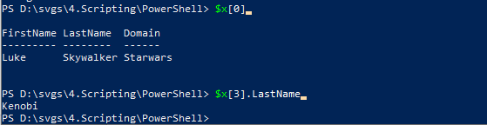

Write a short script using either notepad or the ISE that:

1. Imports the users.csv file into a variable
2. Sorts the variable by last name
3. Outputs the last name of the users  
   #Note: this could be a one-liner  
   #  
   $x = Import-Csv D:\SVGS\4.Scripting\PowerShell\users.csv  
   $x | Sort-Object -Property LastName | Format-Table LastName  
     
   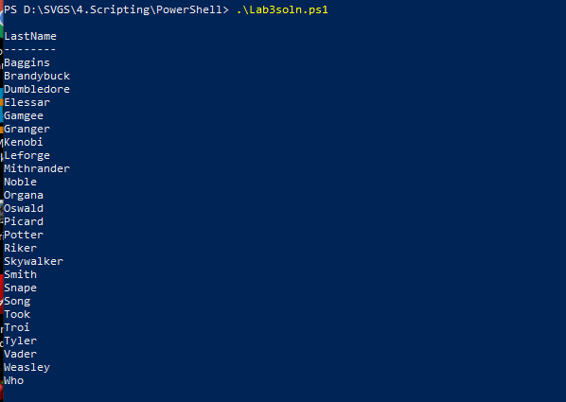

Last answer as a one-liner, not required.  
